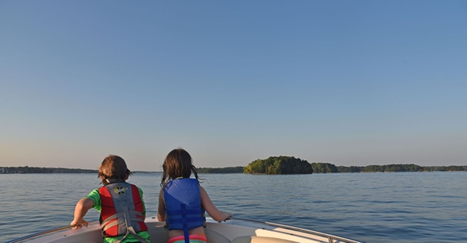 | 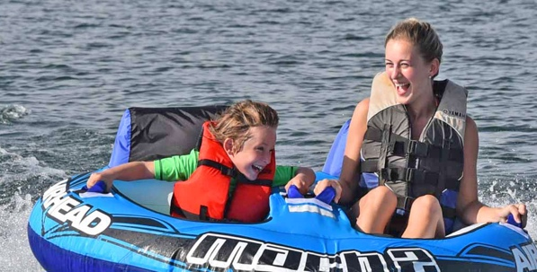 | 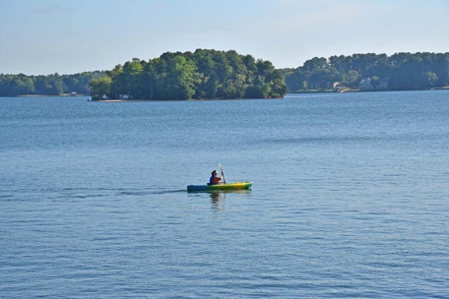

About Lake Norman
more than just a lake…

Lake Norman, 15 miles north of Charlotte, is a fresh-water lake and includes over 535 miles of shoreline, bordering four different counties that include many unique towns surrounding the 32,000 acres of beautiful water. You will find everything from luxurious waterfront property to pastoral farmland with a slightly different vibe in each of the dozens of communities dotting the shore. Its mild four season climate makes it perfect for year-round activities.
One of the first things we like to explain to folks who are interested in the beautiful Lake Norman region of North Carolina is that the term "Lake Norman real estate" encompasses a huge area with a diverse spectrum of people, places, culture, and history.
It represents an entire region from Charlotte to Statesville boasting such incredible diversity of opportunity that there is literally something here for everyone: a place to retire and a place to make a start; a place to work and a place to recreate; a place to explore the past at Revolutionary War landmarks and experience the kinetic world of Nascar.

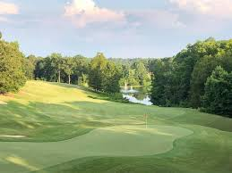 | 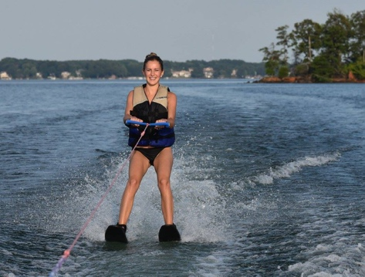 | 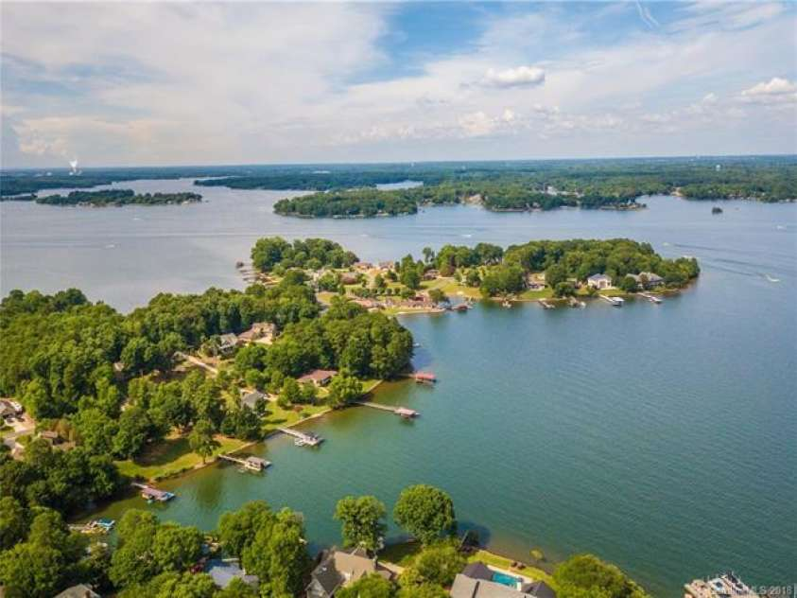

Stepping back from the water, an entirely different lifestyle is available in any of the historic vibrant towns and cities within minutes of the lake as well as stunning new construction and innovative mixed-use development communities.
Please find links below to many Lake Norman area attractions, connections, and community offerings. If you need help locating something that is not listed below, or have a suggestion for a link, please email our broker at scottelliott@remax.net

www.visitlakenorman.org for your ultimate resource

Towns
Town of Mooresville
Town of Cornelius
Town of Davidson
Town of Huntersville
Town of Troutman
City of Statesville
City of Concord
Counties
Mecklenburg
Iredell
Lincoln
Catawba
Cabarrus
Gaston
Rowan
Schools
www.ncpublicschools.org
www.ncreportcards.com
Iredell County Schools
Mooresville City Schools
Charlotte Mecklenburg Schools
Lincoln County Schools
Catawba County Schools
Cabarrus County Schools
Higher Learning
Davidson College
Mitchell Community College
University of North Carolina at Charlotte
Queens University
Belmont Abbey College
Central Piedmont Community College
Hospitals
Lake Norman Regional Hospital
Presbyterian Heathcare
Iredell Memorial Hospital
Davis Regional Medical Center
Cultural Events
Arts and Science Council
Iredell Museums
Davidson Community Players
Mooresville Artist Guild
Iredell Arts Council
Davidson College Friends of the Arts
Lincoln Cultural Center
Loch Norman Highland Games
Fort Dobbs
Miscellaneous Lake Info
Local Weather
Download a map of Lake Norman
Duke Energy Lake Facts, Lake Access & Boat Launch Sites
Check Lake Level
Lake Norman Sail and Power Squadron
Lake Norman State Park
Lake Norman Yacht Club
Lake Preservation Catawba River Keepers
www.catawbariverkeeper.org/
Fun Things To Do
Lazy 5 Ranch Mooresville
Race City Mooresville
Queen's Landing Mooresville
Fishin' With Gus Guided Fishing Tours Lake Norman
Daniel Stowe Botanical Gardens Belmont
NASCAR Speed Park Concord
Carowinds Charlotte
Historic Latta Plantation Huntersville
Carolina Raptor Center Huntersville
U.S. National Whitewater Center Charlotte
Duke Energy Energy Explorium Huntersville
Discovery Place Charlotte
Licensing Info
Fishing License
NC Drivers License & Registration Info
Airports
International - Charlotte/Douglas International Airport Charlotte
Regional - - Statesville Regional Airport Statesville
Rowan County Airport (Salisbury)
Concord Regional Airport
Lincoln County Airport (Lincolnton)
Hickory Regional Airport
Gastonia Municipal Airport
Golf Courses
The Peninsula Club Cornelius
River Run Golf & Country Club Davidson
Verdict Ridge Golf & Country Club Denver
Westport Golf Course Denver
Birkdale Golf Club Huntersville
North Stone Club Huntersville
Skybrook Golf Club Huntersville
Lincoln Country Club Lincolnton
Mallard Head Country Club Mooresville
Mooresville Golf Course Mooresville
Trump National Golf Club, Charlotte Mooresville
Catawba Country Club Newton
Cowan's Ford Country Club Stanley
Fox Den Country Club Statesville
Lakewood Golf Club Statesville
Statesville Country Club Statesville
Twin Oaks Golf Club Statesville
Utility Companies
Telephone
AT&T
Charter
Windstream
MI Connections
Electric
Duke Energy
Energy United
ElectriCities
Rutherford Electric
Gas
PSNC Energy
Energy United
Piedmont Natural Gas

